### Detailed Explanation of the Analysis Report

#### Overview

The analysis conducted on Day 3 focused on understanding several crucial aspects of customer interactions and behaviors with Target in Brazil, leveraging data spanning geographic distributions, order frequencies, average order values, and temporal patterns of orders. This comprehensive analysis aimed to unearth trends and actionable insights that could help refine marketing strategies and optimize overall business operations.

#### Analysis Sections

**1. Geographic Distribution of Customers**

- **Objective**: The analysis aimed to map out where customers are located geographically. Understanding the distribution helps identify regions where the brand is performing well and areas that represent potential growth opportunities.

- **Methodology**: The analysis involved aggregating customer data by state and counting the number of customers per state.

- **Key Findings**: High concentrations of customers were found in economically vibrant and populous states such as São Paulo, Rio de Janeiro, and Minas Gerais. These areas, therefore, represent strongholds where Target has successfully penetrated the market.

- **Implications**: These insights suggest potential for targeted marketing campaigns, strategic placement of new stores, and localized inventory management to cater to the specific needs and preferences of customers in these regions.

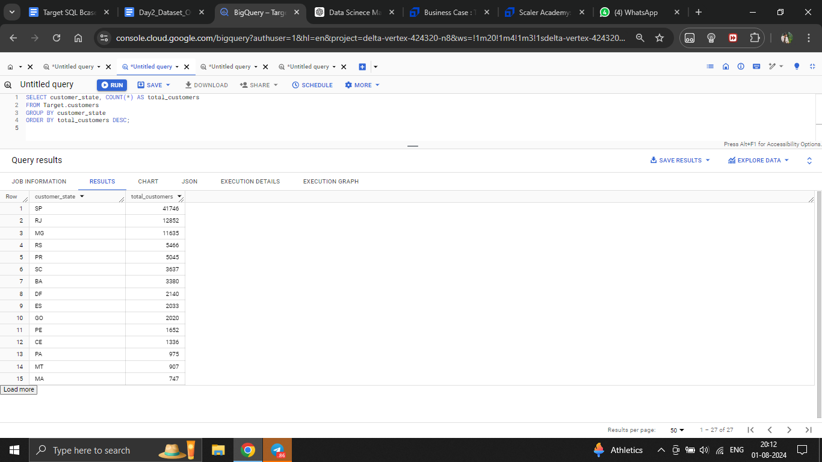

**2. Order Frequency Analysis**

- **Objective**: To determine how frequently individual customers place orders, which helps in identifying loyal customers and understanding customer engagement levels.

- **Methodology**: Orders per customer were tallied to reveal the frequency of purchases, highlighting both occasional and frequent shoppers.

- **Key Findings**: A small segment of customers was identified as frequent buyers, indicating a strong brand loyalty within this group.

- **Implications**: This information is vital for developing loyalty programs and personalized marketing strategies aimed at increasing the frequency of purchases among existing customers and converting occasional buyers into regular ones.

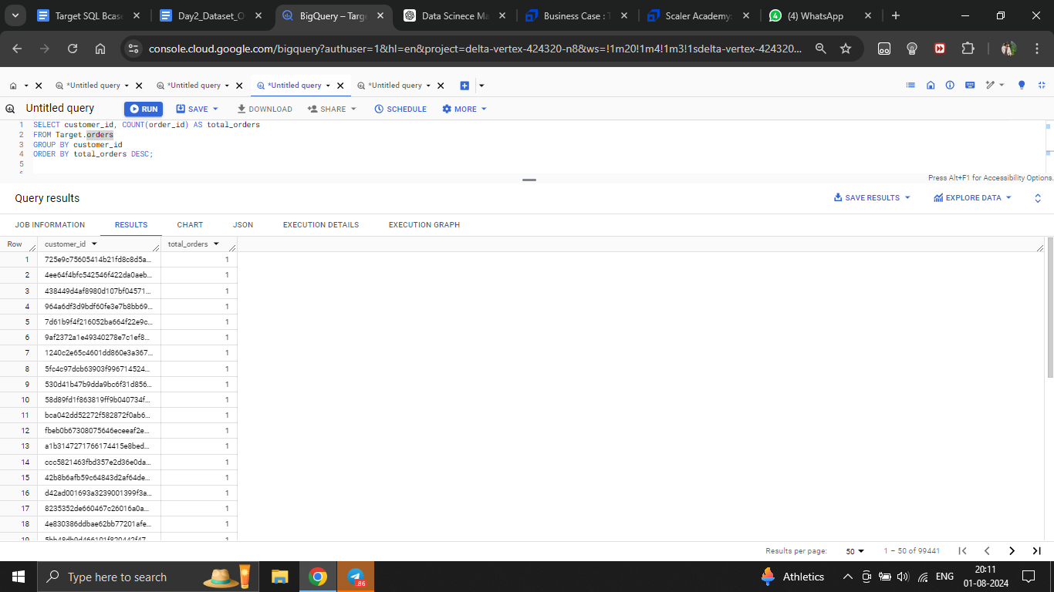

**3. Average Order Value Analysis**

- **Objective**: Analyzing the average spending per order by customers to gauge financial engagement and identify high-value customers.

- **Methodology**: Calculated the average monetary value of orders placed by each customer.

- **Key Findings**: There was significant variability in order values, with a subset of customers consistently spending above the average. These high-value customers are crucial to the brand’s revenue.

- **Implications**: Insights from this analysis can guide tailored marketing initiatives, such as upselling and cross-selling strategies, to boost the average order value across various customer segments.

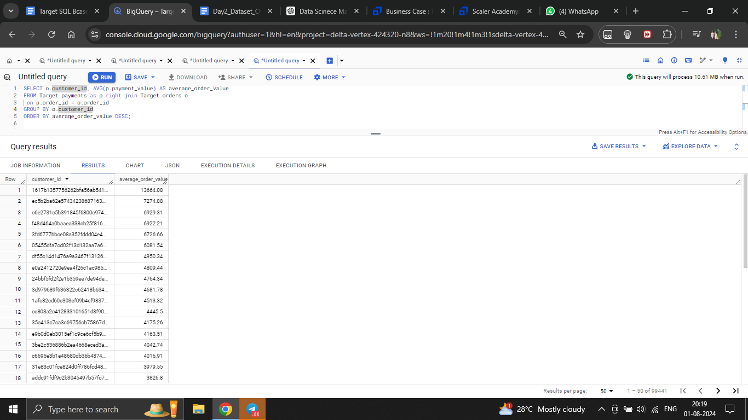

**4. Order Timing Analysis**

- **Objective**: To discover patterns regarding the times of day and days of the week when orders are most frequently placed.

- **Methodology**: The data was analyzed to extract the frequency of orders across different hours of the day and days of the week.

- **Key Findings**: Peak ordering times were identified 2nd half of the day, particularly around 12 Noon to 10 PM. This pattern suggests when customers are most likely to engage with the brand.

- **Implications**: This information is instrumental for scheduling promotions, optimizing staff shifts, and planning stock levels to align with peak demand times, thereby enhancing customer service and operational efficiency.

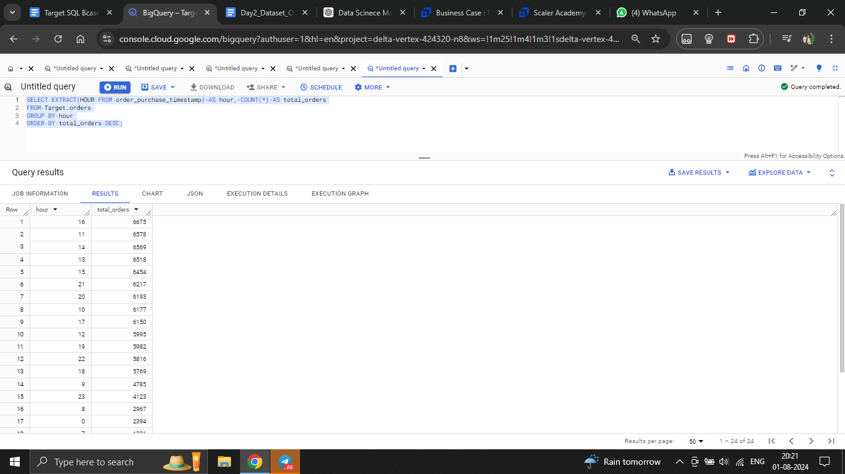

### Conclusion

The Day 3 analysis provides Target with a robust framework to understand their customer base in Brazil deeply. The insights derived from geographic distributions, purchasing frequencies, spending behaviors, and ordering times equip Target with the necessary data to refine their operational and marketing strategies effectively. The next steps involve implementing targeted actions based on these insights to enhance customer satisfaction, increase sales, and optimize resource allocation.